DHT-11 & NodeMCU Project

**Aim:** To record room Temperature and Humidity using Dht-11 sensor and NodeMCU. The current Temperature and Humidity readings will be displayed on “Adafruit.io”.

**Hardware Components:**

* NodeMCU
* DHT11 Humidity and Temperature sensor
* Breadboard
* Jumper Wires (Optional)
* Micro USB Cable

**Software Components:**

* Arduino IDE

**Working of Sensor:**

Humidity Part:

The DHT11 detects water vapor by measuring the electrical resistance between two electrodes.

The humidity sensing component is a moisture holding substrate with electrodes applied to the surface. When water vapor is absorbed by the substrate, ions are released by the substrate which increases the conductivity between the electrodes. The change in resistance between the two electrodes is proportional to the relative humidity. Higher relative humidity decreases the resistance between the electrodes, while lower relative humidity increases the resistance between the electrodes.

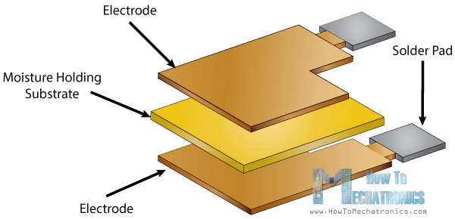

Temperature Part:

For measuring temperature these sensors use a NTC temperature sensor or a thermistor.

A thermistor is actually a variable resistor that changes its resistance with change of the temperature. These sensors are made by sintering of semiconductive materials such as ceramics or polymers in order to provide larger changes in the resistance with just small changes in temperature.

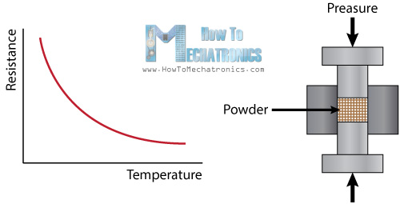

The term “NTC” means “Negative Temperature Coefficient”, which means that the resistance decreases with increase of the temperature.

**Dht-11 Pins:**

There are two type of Dht-11's available in the market, one with four pins and another with three pins.

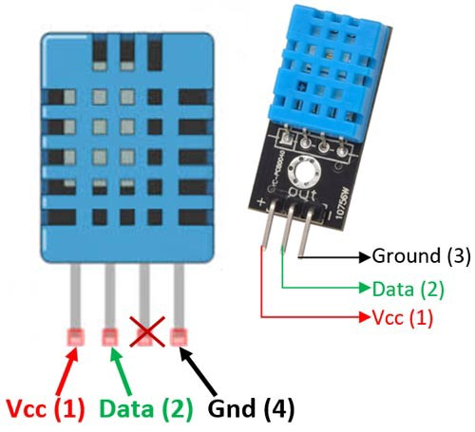

**Connections:**

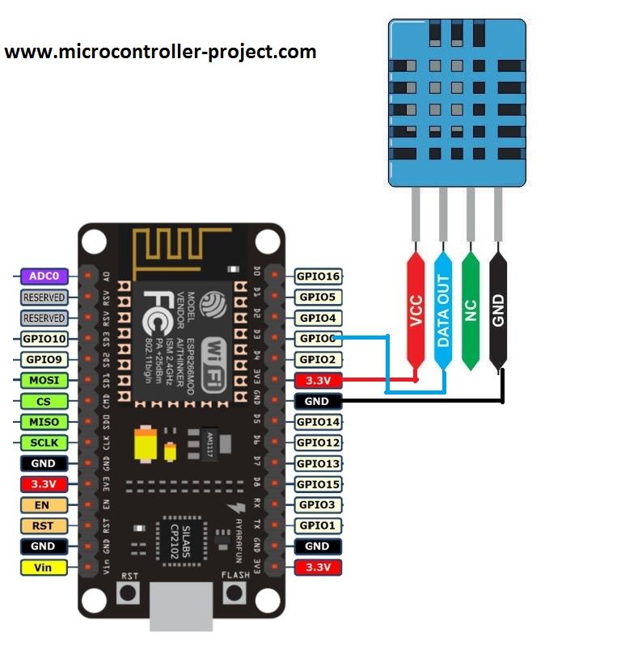

* Vcc Pin of the DHT-11 goes into 3.3V of the NodeMCU.
* Data Out Pin of the DHT-11 goes into D3(GPIO0) of the NodeMCU
* GND Pin of the DHT-11 goes into Ground Pin(GND) of the NodeMCU

**Code:**

Write the code in the Arduino IDE application.

Complete Code is available in the below link.

Write your wifi parameters and Adafruit IO details as mentioned below -

<https://drive.google.com/file/d/1Mn3QwtTGPjPZPoX6MK3l1rnCug7i8iBH/view?usp=sharing>

**Adafruit Setup:**

1) After Opening Adafruit.io >> Go “Feeds” from the top bar menu.

2) Click on “+ New Feed” button and create **two** feeds(e.g Temperature & Humidity)

3) Now click on “Dashboards” from the top menu.

4) Click on “+ New Dashboard” button on top-left hand side

5) Give it a name (e.g. Temperature and Humidity Readings) >> Open your created Dashboard

6) Click on Settings Button on top-right hand side >> Click on “Create New Block” >> Select “Gauge”

7) Select one of the created feed from the list >> Click on “Next Step”

8) Edit necessary items >> Click on “Create Block”

9) Repeat the same for the second feed as well.

10) Now Click On “My Key” from top bar menu >> Copy both “username” & “Active Key” And paste it in the Code given

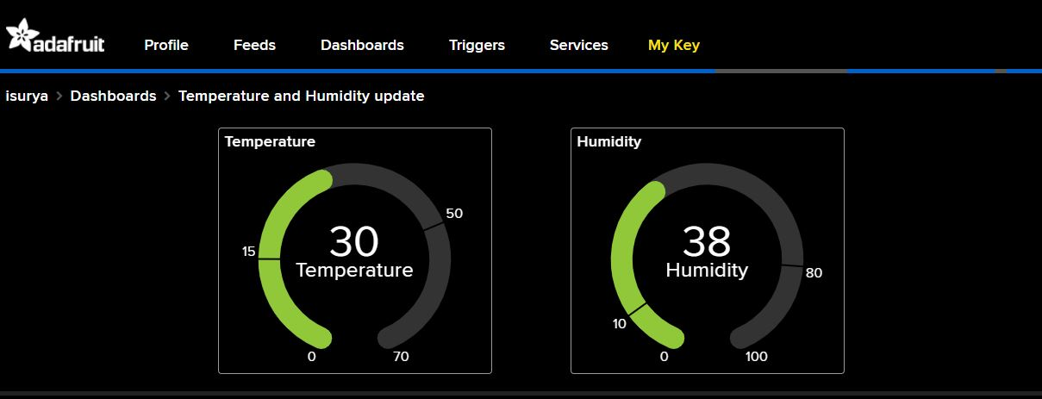

**Output:**

The Values keep updating for every 5 seconds...



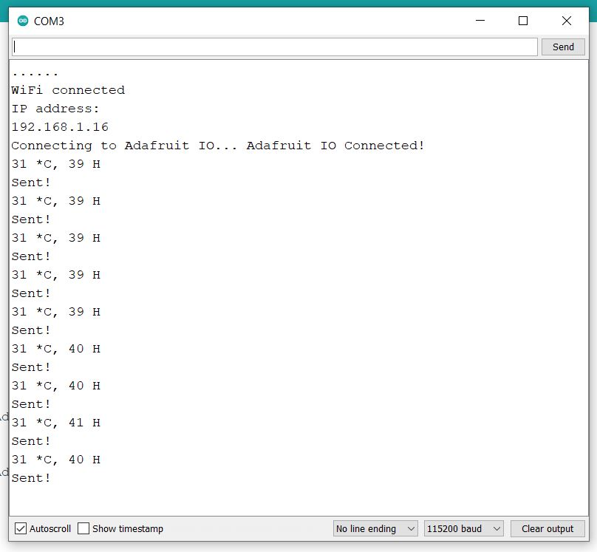

Arduiono Serial Monitor Output...

**Snap of Circuitry:**

